**CSCI334 Software Design**

**Lab – Week 4**

**Solution**

DataSafe is software service providing secure and convenient data storage and recovery that is accessible from the Internet. DataSafe provides the following features:

* Customers may upload, store, and download data of any kind
* Uploaded data is guaranteed to be secure and safe from loss or corruption
* Organizations may control who has access to data on a file-by-file basis
* Data may be searched and viewed in many ways
* DataSafe is a client-server system implemented as a web service available to clients through a browser.

Use the architectural styles discussed in the reading to generate two architectural designs for the DataSafe server.

Document your design with a **decomposition diagram** and brief descriptions of the **responsibilities** of each architectural component.

1. We can use layered architecture style or client-server architecture style here.

Practically, a combination of the client-server and multiple layered architecture is easier to design and setup.

Repository pattern (too monolithic)

The system designed by a layered architecture.

A modular decomposition of the system.

Base analysis on the **Box-and-Line Diagram similar to the following:**

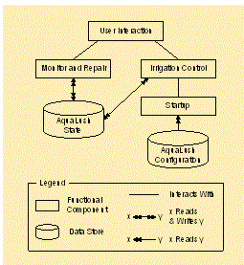

User Interface

authentication

authorization

File operation Layer

Upload file

Validate file

search file

File Storage Layer

(repository pattern

Can be used）

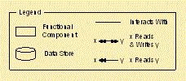



|  |  |
| --- | --- |
| component | Responsiblity |
| User interface | Provide a user interface for the system |
| Authentication | Check the access of the user |
| Authorization | Validate the access rights of the user |
|  |  |
|  |  |
|  |  |